statistical thinking 2-5 DataCamp course note

# !wget https://assets.datacamp.com/production/course_1550/datasets/finch_beaks_1975.csv
# !wget https://assets.datacamp.com/production/course_1550/datasets/finch_beaks_2012.csv
import numpy as np
import matplotlib.pyplot as plt
import seaborn as sns
import pandas as pd
df1 = pd.read_csv('./finch_beaks_1975.csv')
df2 = pd.read_csv('./finch_beaks_2012.csv')
df1.shape, df2.shape
((403, 4), (248, 4))
df1.head()
 | band | species | Beak length, mm | Beak depth, mm
0 | 2 | fortis | 9.4 | 8.0
1 | 9 | fortis | 9.2 | 8.3
2 | 12 | fortis | 9.5 | 7.5
3 | 15 | fortis | 9.5 | 8.0
4 | 305 | fortis | 11.5 | 9.9
df2.head()
 | band | species | blength | bdepth
0 | 19022 | fortis | 10.0 | 8.5
1 | 19028 | fortis | 12.5 | 8.9
2 | 19032 | fortis | 9.3 | 7.5
3 | 19041 | fortis | 10.3 | 9.6
4 | 19044 | fortis | 11.0 | 9.2
names = ['band','species','beak_length','beak_depth']
df1.columns=names
df2.columns=names
df1['year']=1975
df2['year']=2012

EDA of beak depths of Darwin's finches
For your first foray into the Darwin finch data, you will study how the beak depth (the distance, top to bottom, of a closed beak) of the finch species Geospiza scandens has changed over time. The Grants have noticed some changes of beak geometry depending on the types of seeds available on the island, and they also noticed that there was some interbreeding with another major species on Daphne Major, Geospiza fortis. These effects can lead to changes in the species over time.
In the next few problems, you will look at the beak depth of G. scandens on Daphne Major in 1975 and in 2012. To start with, let's plot all of the beak depth measurements in 1975 and 2012 in a bee swarm plot.
The data are stored in a pandas DataFrame called df with columns 'year' and 'beak_depth'. The units of beak depth are millimeters (mm).
df=pd.concat([df1, df2])
df.head()
 | band | species | beak_length | beak_depth | year
0 | 2 | fortis | 9.4 | 8.0 | 1975
1 | 9 | fortis | 9.2 | 8.3 | 1975
2 | 12 | fortis | 9.5 | 7.5 | 1975
3 | 15 | fortis | 9.5 | 8.0 | 1975
4 | 305 | fortis | 11.5 | 9.9 | 1975
plt.figure(figsize=(12,7))
# Create bee swarm plot
_ = sns.swarmplot(data=df, x='year', y='beak_depth')

# Label the axes
_ = plt.xlabel('year')
_ = plt.ylabel('beak depth (mm)')

# Show the plot
plt.show()
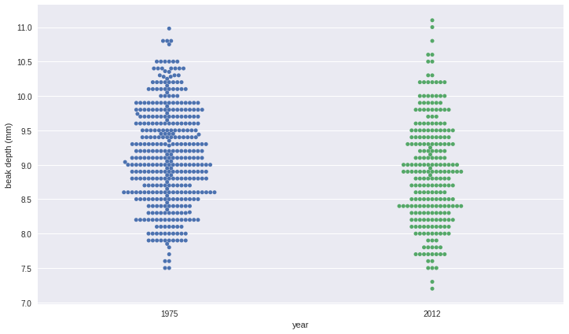
def ecdf(data):
y=np.arange(1, len(data)+1)/float(len(data))
x=np.sort(data)
return x,y

ECDFs of beak depths
While bee swarm plots are useful, we found that ECDFs are often even better when doing EDA. Plot the ECDFs for the 1975 and 2012 beak depth measurements on the same plot.
For your convenience, the beak depths for the respective years has been stored in the NumPy arrays bd_1975 and bd_2012.
bd_1975 = df1['beak_depth'].values
bd_2012 = df2['beak_depth'].values
plt.figure(figsize=(12,7))

# Compute ECDFs
x_1975, y_1975 = ecdf(bd_1975)
x_2012, y_2012 = ecdf(bd_2012)

# Plot the ECDFs
_ = plt.plot(x_1975, y_1975, marker='.', linestyle='none')
_ = plt.plot(x_2012, y_2012, marker='.', linestyle='none')

# Set margins
plt.margins(0.02)

# Add axis labels and legend
_ = plt.xlabel('beak depth (mm)')
_ = plt.ylabel('ECDF')
_ = plt.legend(('1975', '2012'), loc='lower right')

# Show the plot
plt.show()
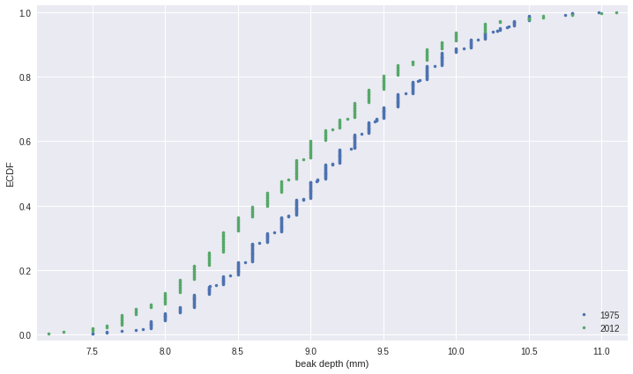

Parameter estimates of beak depths
Estimate the difference of the mean beak depth of the G. scandens samples from 1975 and 2012 and report a 95% confidence interval.
Since in this exercise you will use the draw_bs_reps() function you wrote in chapter 2, it may be helpful to refer back to it.
from statcamp import draw_bs_reps, draw_bs_pairs_linreg
# Compute the difference of the sample means: mean_diff
mean_diff = np.mean(bd_2012) - np.mean(bd_1975)

# Get bootstrap replicates of means
bs_replicates_1975 = draw_bs_reps(bd_1975, np.mean, 10000)
bs_replicates_2012 = draw_bs_reps(bd_2012, np.mean, 10000)

# Compute samples of difference of means: bs_diff_replicates
bs_diff_replicates = bs_replicates_2012 - bs_replicates_1975

# Compute 95% confidence interval: conf_int
conf_int = np.percentile(bs_diff_replicates, [2.5, 97.5])

# Print the results
print('difference of means =', mean_diff, 'mm')
print('95% confidence interval =', conf_int, 'mm')
('difference of means =', -0.22313275434243174, 'mm')
('95% confidence interval =', array([-0.34053412, -0.1052866 ]), 'mm')

Hypothesis test: Are beaks deeper in 2012?
Your plot of the ECDF and determination of the confidence interval make it pretty clear that the beaks of G. scandens on Daphne Major have gotten deeper. But is it possible that this effect is just due to random chance? In other words, what is the probability that we would get the observed difference in mean beak depth if the means were the same?
Be careful! The hypothesis we are testing is not that the beak depths come from the same distribution. For that we could use a permutation test. The hypothesis is that the means are equal. To perform this hypothesis test, we need to shift the two data sets so that they have the same mean and then use bootstrap sampling to compute the difference of means.
# Compute mean of combined data set: combined_mean
combined_mean = np.mean(np.concatenate((bd_1975, bd_2012)))

# Shift the samples
bd_1975_shifted = bd_1975 - np.mean(bd_1975) + combined_mean
bd_2012_shifted = bd_2012 - np.mean(bd_2012) + combined_mean

# Get bootstrap replicates of shifted data sets
bs_replicates_1975 = draw_bs_reps(bd_1975_shifted, np.mean, 10000)
bs_replicates_2012 = draw_bs_reps(bd_2012_shifted, np.mean, 10000)

# Compute replicates of difference of means: bs_diff_replicates
bs_diff_replicates = bs_replicates_2012 - bs_replicates_1975

# Compute the p-value: p
p = np.sum(bs_diff_replicates >= mean_diff) / float(len(bs_diff_replicates))

# Print p-value
print('p =', p)
('p =', 0.9999)

EDA of beak length and depth
The beak length data are stored as bl_1975 and bl_2012, again with units of millimeters (mm). You still have the beak depth data stored in bd_1975 and bd_2012. Make scatter plots of beak depth (y-axis) versus beak length (x-axis) for the 1975 and 2012 specimens.
df.head()
 | band | species | beak_length | beak_depth | year
0 | 2 | fortis | 9.4 | 8.0 | 1975
1 | 9 | fortis | 9.2 | 8.3 | 1975
2 | 12 | fortis | 9.5 | 7.5 | 1975
3 | 15 | fortis | 9.5 | 8.0 | 1975
4 | 305 | fortis | 11.5 | 9.9 | 1975
bl_1975=df[df['year']==1975]['beak_length'].values
bd_1975=df[df['year']==1975]['beak_depth'].values
bl_2012=df[df['year']==2012]['beak_length'].values
bd_2012=df[df['year']==2012]['beak_depth'].values
plt.figure(figsize=(12,7))

# Make scatter plot of 1975 data
_ = plt.plot(bl_1975, bd_1975, marker='.',
linestyle='none', color='blue', alpha=0.5)

# Make scatter plot of 2012 data
_ = plt.plot(bl_2012, bd_2012, marker='.',
linestyle='none', color='red', alpha=0.5)

# Label axes and make legend
_ = plt.xlabel('beak length (mm)')
_ = plt.ylabel('beak depth (mm)')
_ = plt.legend(('1975', '2012'), loc='upper left')

# Show the plot
plt.show()
<matplotlib.figure.Figure at 0x7fe542c79a10>
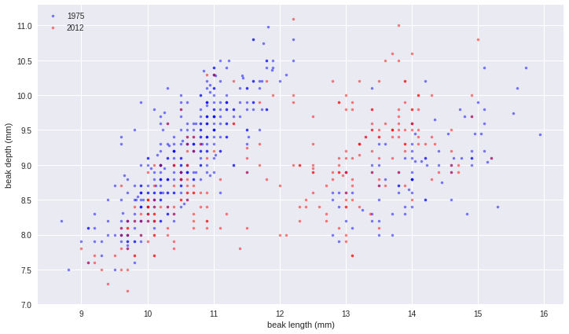

Linear regressions
Perform a linear regression for both the 1975 and 2012 data. Then, perform pairs bootstrap estimates for the regression parameters. Report 95% confidence intervals on the slope and intercept of the regression line.
You will use the draw_bs_pairs_linreg() function you wrote back in chapter 2.
As a reminder, its call signature is draw_bs_pairs_linreg(x, y, size=1), and it returns bs_slope_reps and bs_intercept_reps.
# Compute the linear regressions
slope_1975, intercept_1975 = np.polyfit(bl_1975, bd_1975, 1)
slope_2012, intercept_2012 = np.polyfit(bl_2012, bd_2012, 1)

# Perform pairs bootstrap for the linear regressions
bs_slope_reps_1975, bs_intercept_reps_1975 = \
draw_bs_pairs_linreg(bl_1975, bd_1975, 1000)
bs_slope_reps_2012, bs_intercept_reps_2012 = \
draw_bs_pairs_linreg(bl_2012, bd_2012, 1000)

# Compute confidence intervals of slopes
slope_conf_int_1975 = np.percentile(bs_slope_reps_1975, [2.5, 97.5])
slope_conf_int_2012 = np.percentile(bs_slope_reps_2012, [2.5, 97.5])
intercept_conf_int_1975 = np.percentile(
bs_intercept_reps_1975, [2.5, 97.5])
intercept_conf_int_2012 = np.percentile(
bs_intercept_reps_2012, [2.5, 97.5])

# Print the results
print('1975: slope =', slope_1975,
'conf int =', slope_conf_int_1975)
print('1975: intercept =', intercept_1975,
'conf int =', intercept_conf_int_1975)
print('2012: slope =', slope_2012,
'conf int =', slope_conf_int_2012)
print('2012: intercept =', intercept_2012,
'conf int =', intercept_conf_int_2012)
('1975: slope =', 0.09459683208921148, 'conf int =', array([0.05639577, 0.13146657]))
('1975: intercept =', 8.053907980716426, 'conf int =', array([7.63641605, 8.49427785]))
('2012: slope =', 0.279421483961125, 'conf int =', array([0.23613954, 0.32067878]))
('2012: intercept =', 5.548559204612315, 'conf int =', array([5.05508437, 6.0412641 ]))

Displaying the linear regression results
Now, you will display your linear regression results on the scatter plot, the code for which is already pre-written for you from your previous exercise. To do this, take the first 100 bootstrap samples (stored in bs_slope_reps_1975, bs_intercept_reps_1975, bs_slope_reps_2012, and bs_intercept_reps_2012) and plot the lines with alpha=0.2 and linewidth=0.5 keyword arguments to plt.plot().
plt.figure(figsize=(12,7))

# Make scatter plot of 1975 data
_ = plt.plot(bl_1975, bd_1975, marker='.',
linestyle='none', color='blue', alpha=0.5)

# Make scatter plot of 2012 data
_ = plt.plot(bl_2012, bd_2012, marker='.',
linestyle='none', color='red', alpha=0.5)

# Label axes and make legend
_ = plt.xlabel('beak length (mm)')
_ = plt.ylabel('beak depth (mm)')
_ = plt.legend(('1975', '2012'), loc='upper left')

# Generate x-values for bootstrap lines: x
x = np.array([10, 17])

# Plot the bootstrap lines
for i in range(100):
plt.plot(x, bs_slope_reps_1975[i] * x + bs_intercept_reps_1975[i],
linewidth=0.5, alpha=0.2, color='blue')
plt.plot(x, bs_slope_reps_2012[i] * x + bs_intercept_reps_2012[i],
linewidth=0.5, alpha=0.2, color='red')

# Draw the plot again
plt.show()
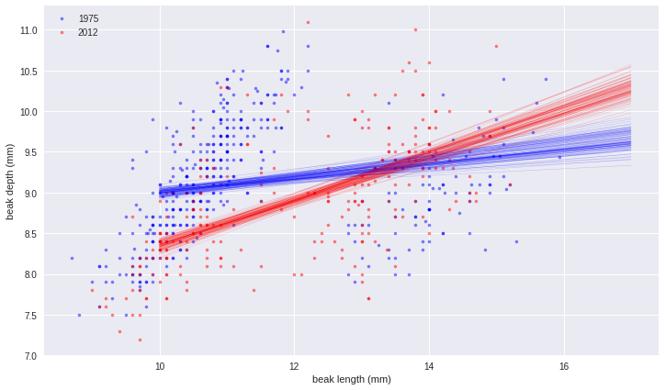

Beak length to depth ratio
The linear regressions showed interesting information about the beak geometry. The slope was the same in 1975 and 2012, suggesting that for every millimeter gained in beak length, the birds gained about half a millimeter in depth in both years. However, if we are interested in the shape of the beak, we want to compare the ratio of beak length to beak depth. Let's make that comparison.
Remember, the data are stored in bd_1975, bd_2012, bl_1975, and bl_2012.
# Compute length-to-depth ratios
ratio_1975 = bl_1975 / bd_1975
ratio_2012 = bl_2012 / bd_2012

# Compute means
mean_ratio_1975 = np.mean(ratio_1975)
mean_ratio_2012 = np.mean(ratio_2012)

# Generate bootstrap replicates of the means
bs_replicates_1975 = draw_bs_reps(ratio_1975, np.mean, size=10000)
bs_replicates_2012 = draw_bs_reps(ratio_2012, np.mean, size=10000)

# Compute the 99% confidence intervals
conf_int_1975 = np.percentile(bs_replicates_1975, [0.5, 99.5])
conf_int_2012 = np.percentile(bs_replicates_2012, [0.5, 99.5])

# Print the results
print('1975: mean ratio =', mean_ratio_1975,
'conf int =', conf_int_1975)
print('2012: mean ratio =', mean_ratio_2012,
'conf int =', conf_int_2012)
('1975: mean ratio =', 1.2461609991094327, 'conf int =', array([1.22250396, 1.27029518]))
('2012: mean ratio =', 1.3483617710027853, 'conf int =', array([1.32418645, 1.37287768]))

EDA of heritability
The array bd_parent_scandens contains the average beak depth (in mm) of two parents of the species G. scandens. The array bd_offspring_scandens contains the average beak depth of the offspring of the respective parents. The arrays bd_parent_fortis and bd_offspring_fortis contain the same information about measurements from G. fortis birds.
Make a scatter plot of the average offspring beak depth (y-axis) versus average parental beak depth (x-axis) for both species. Use the alpha=0.5 keyword argument to help you see overlapping points.
# !wget https://assets.datacamp.com/production/course_1550/datasets/fortis_beak_depth_heredity.csv
# ! wget https://assets.datacamp.com/production/course_1550/datasets/scandens_beak_depth_heredity.csv
df3=pd.read_csv('./fortis_beak_depth_heredity.csv')
df4=pd.read_csv('./scandens_beak_depth_heredity.csv')
df3.shape, df4.shape
((413, 3), (130, 2))
df3.head()
 | Mid-offspr | Male BD | Female BD
0 | 10.70 | 10.90 | 9.3
1 | 9.78 | 10.70 | 8.4
2 | 9.48 | 10.70 | 8.1
3 | 9.60 | 10.70 | 9.8
4 | 10.27 | 9.85 | 10.4
df4.head()
 | mid_parent | mid_offspring
0 | 8.3318 | 8.4190
1 | 8.4035 | 9.2468
2 | 8.5317 | 8.1532
3 | 8.7202 | 8.0089
4 | 8.7089 | 8.2215
bd_parent_fortis = (df3['Male BD'].values + df3['Female BD'].values)/2
bd_offspring_fortis = df3['Mid-offspr'].values
bd_parent_scandens = df4['mid_parent'].values
bd_offspring_scandens = df4['mid_offspring'].values
plt.figure(figsize=(12,7))

# Make scatter plots
_ = plt.plot(bd_parent_fortis, bd_offspring_fortis,
marker='.', linestyle='none', color='blue', alpha=0.5)
_ = plt.plot(bd_parent_scandens, bd_offspring_scandens,
marker='.', linestyle='none', color='red', alpha=0.5)

# Set margins, make legend, label axes, and show plot
plt.margins(0.02)

# Label axes
_ = plt.xlabel('parental beak depth (mm)')
_ = plt.ylabel('offspring beak depth (mm)')

# Add legend
_ = plt.legend(('G. fortis', 'G. scandens'), loc='lower right')

# Show plot
plt.show()
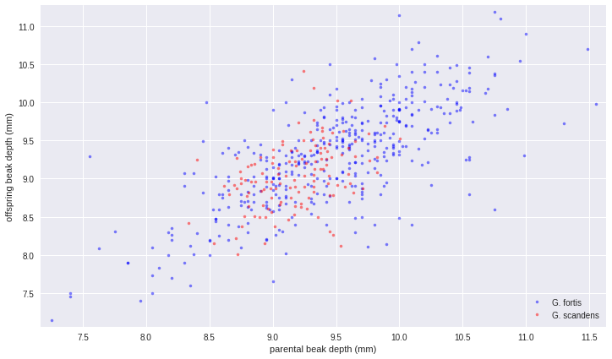

Correlation of offspring and parental data
In an effort to quantify the correlation between offspring and parent beak depths, we would like to compute statistics, such as the Pearson correlation coefficient, between parents and offspring. To get confidence intervals on this, we need to do a pairs bootstrap.
You have already written a function to do pairs bootstrap to get estimates for parameters derived from linear regression. Your task in this exercise is to modify that function to make a new function with call signature draw_bs_pairs(x, y, func, size=1) that performs pairs bootstrap and computes a single statistic on the pairs samples defined by func(bs_x, bs_y). In the next exercise, you will use pearson_r for func.
def draw_bs_pairs(x, y, func, size=1):
"""Perform pairs bootstrap for single statistic."""

# Set up array of indices to sample from: inds
inds = np.arange(len(x))

# Initialize replicates: bs_replicates
bs_replicates = np.empty(size)

# Generate replicates
for i in range(size):
bs_inds = np.random.choice(inds, len(inds))
bs_x, bs_y = x[bs_inds], y[bs_inds]
bs_replicates[i] = func(bs_x, bs_y)

return bs_replicates
df4.head()
 | mid_parent | mid_offspring
0 | 8.3318 | 8.4190
1 | 8.4035 | 9.2468
2 | 8.5317 | 8.1532
3 | 8.7202 | 8.0089
4 | 8.7089 | 8.2215
sns.pairplot(df4)
plt.show()
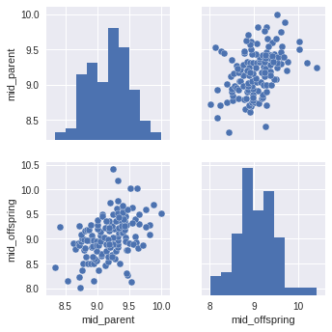

Pearson correlation of offspring and parental data
The Pearson correlation coefficient seems like a useful measure of how strongly the beak depth of parents are inherited by their offspring. Compute the Pearson correlation coefficient between parental and offspring beak depths for G. scandens. Do the same for G. fortis. Then, use the function you wrote in the last exercise to compute a 95% confidence interval using pairs bootstrap.
Remember, the data are stored in bd_parent_scandens, bd_offspring_scandens, bd_parent_fortis, and bd_offspring_fortis.
from statcamp import pearson_r
# Compute the Pearson correlation coefficients
r_scandens = pearson_r(bd_parent_scandens, bd_offspring_scandens)
r_fortis = pearson_r(bd_parent_fortis, bd_offspring_fortis)

# Acquire 1000 bootstrap replicates of Pearson r
bs_replicates_scandens = draw_bs_pairs(
bd_parent_scandens, bd_offspring_scandens, pearson_r, size=1000)
bs_replicates_fortis = draw_bs_pairs(
bd_parent_fortis, bd_offspring_fortis, pearson_r, size=1000)

# Compute 95% confidence intervals
conf_int_scandens = np.percentile(bs_replicates_scandens, [2.5, 97.5])
conf_int_fortis = np.percentile(bs_replicates_fortis, [2.5, 97.5])

# Print results
print('G. scandens:', r_scandens, conf_int_scandens)
print('G. fortis:', r_fortis, conf_int_fortis)
('G. scandens:', 0.4117063629401258, array([0.25808255, 0.53982473]))
('G. fortis:', 0.7283412395518487, array([0.66821135, 0.77902536]))

Measuring heritability
Remember that the Pearson correlation coefficient is the ratio of the covariance to the geometric mean of the variances of the two data sets. This is a measure of the correlation between parents and offspring, but might not be the best estimate of heritability. If we stop and think, it makes more sense to define heritability as the ratio of the covariance between parent and offspring to the variance of the parents alone. In this exercise, you will estimate the heritability and perform a pairs bootstrap calculation to get the 95% confidence interval.
This exercise highlights a very important point. Statistical inference (and data analysis in general) is not a plug-n-chug enterprise. You need to think carefully about the questions you are seeking to answer with your data and analyze them appropriately. If you are interested in how heritable traits are, the quantity we defined as the heritability is more apt than the off-the-shelf statistic, the Pearson correlation coefficient.
Remember, the data are stored in bd_parent_scandens, bd_offspring_scandens, bd_parent_fortis, and bd_offspring_fortis.
def heritability(parents, offspring):
"""Compute the heritability from parent and offspring samples."""
covariance_matrix = np.cov(parents, offspring)
return covariance_matrix[0,1] / covariance_matrix[0,0]

# Compute the heritability
heritability_scandens = heritability(bd_parent_scandens,
bd_offspring_scandens)
heritability_fortis = heritability(bd_parent_fortis,
bd_offspring_fortis)

# Acquire 1000 bootstrap replicates of heritability
replicates_scandens = draw_bs_pairs(
bd_parent_scandens, bd_offspring_scandens, heritability, size=1000)
replicates_fortis = draw_bs_pairs(
bd_parent_fortis, bd_offspring_fortis, heritability, size=1000)

# Compute 95% confidence intervals
conf_int_scandens = np.percentile(replicates_scandens, [2.5, 97.5])
conf_int_fortis = np.percentile(replicates_fortis, [2.5, 97.5])

# Print results
print('G. scandens:', heritability_scandens, conf_int_scandens)
print('G. fortis:', heritability_fortis, conf_int_fortis)
('G. scandens:', 0.5485340868685982, array([0.35462022, 0.73738307]))
('G. fortis:', 0.7229051911438159, array([0.6541286 , 0.79924218]))

Is beak depth heritable at all in G. scandens?
The heritability of beak depth in G. scandens seems low. It could be that this observed heritability was just achieved by chance and beak depth is actually not really heritable in the species. You will test that hypothesis here. To do this, you will do a pairs permutation test.
# Initialize array of replicates: perm_replicates
perm_replicates = np.empty(10000)

# Draw replicates
for i in range(10000):
# Permute parent beak depths
bd_parent_permuted = np.random.permutation(bd_parent_scandens)
perm_replicates[i] = heritability(bd_parent_permuted,
bd_offspring_scandens)

# Compute p-value: p
p = np.sum(perm_replicates >= heritability_scandens) / float(len(perm_replicates))

# Print the p-value
print('p-val =', p)

('p-val =', 0.0)
>>>>>>>>>>>>>>>>>>>>>>>>>>..

Linear regressions
Perform a linear regression for both the 1975 and 2012 data. Then, perform pairs bootstrap estimates for the regression parameters. Report 95% confidence intervals on the slope and intercept of the regression line.
You will use the draw_bs_pairs_linreg() function you wrote back in chapter 2.
As a reminder, its call signature is draw_bs_pairs_linreg(x, y, size=1), and it returns bs_slope_reps and bs_intercept_reps.

Instructions
100xp
- Compute the slope and intercept for both the 1975 and 2012 data sets.
- Obtain 1000 pairs bootstrap samples for the linear regressions using your draw_bs_pairs_linreg() function.
- Compute 95% confidence intervals for the slopes and the intercepts.
# Compute the linear regressions
slope_1975, intercept_1975 = np.polyfit(bl_1975, bd_1975, 1)
slope_2012, intercept_2012 = np.polyfit(bl_2012, bd_2012, 1)

# Perform pairs bootstrap for the linear regressions
bs_slope_reps_1975, bs_intercept_reps_1975 = \
draw_bs_pairs_linreg(bl_1975, bd_1975, 1000)
bs_slope_reps_2012, bs_intercept_reps_2012 = \
draw_bs_pairs_linreg(bl_2012, bd_2012, 1000)

# Compute confidence intervals of slopes
slope_conf_int_1975 = np.percentile(bs_slope_reps_1975, [2.5, 97.5])
slope_conf_int_2012 = np.percentile(bs_slope_reps_2012, [2.5, 97.5])
intercept_conf_int_1975 = np.percentile(
bs_intercept_reps_1975, [2.5, 97.5])
intercept_conf_int_2012 = np.percentile(
bs_intercept_reps_2012, [2.5, 97.5])

# Print the results
print('1975: slope =', slope_1975,
'conf int =', slope_conf_int_1975)
print('1975: intercept =', intercept_1975,
'conf int =', intercept_conf_int_1975)
print('2012: slope =', slope_2012,
'conf int =', slope_conf_int_2012)
print('2012: intercept =', intercept_2012,
'conf int =', intercept_conf_int_2012)

